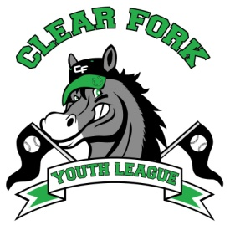
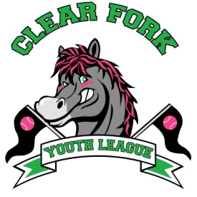
BOARD MEETING
NOVEMBER 6, 2018
Attendance:
Jay Vail
Mike Hoeflich
Allen Leech
Ashley Ludwig
David Myers
Josh Smith
Carrie Knight
Lindsay Roberts
Chris Kindt

- Allen
  - Received our new EIN number
  - Filed 1023ez, wait time is 90 days, should have answer by January 2019
  - Unstoppables will join our bank account and EIN, Allen and Lindsay will track money and donations
  - Presented the possibility of allowing Clear Fork youth soccer and football to also join our EIN
    - Went over pros and cons, all scenarios
    - Voted YES to merge
    - Brainstormed possible people to create a Board over all sports groups
  - Suggested hosting an auction for companies to sponsor the fields
    - Mike mentioned field #1 is already named Bowman Field and #2 is Carol Lifer Field
      - Would keep those names and add “Sponsored by”
      - Field #4 will be on school property once rebuilt, will check into if we can auction naming rights to that field
    - Mike will call Chuck Whatman to see if he would be willing to do the auctioning and his available dates
    - We will provide phone representatives for anyone wanting to attend but are unable to
  - Went over list of potential sponsors
    - Ashley will finalize the sponsor letter and form, create an auction flyer and print all
  - We need to make public notice of all meetings
    - Will meet 2nd Wednesday @ 7:00 every month, location to be determined

- Next Board Meeting December 12, 2018, 7:00 @ Brumby’s

